**Press Release for Immediate Release**

**SOWETO THEATRE PROUDLY ANNOUNCES THE ARTIST RESIDENCY PROGRAMME AS PART OF THE MUSIC TUTORIAL PROGRAMME**

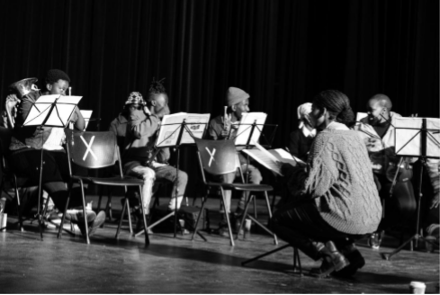

Soweto Theatre is proud to announce Gabi Motuba as their first artist for the residency from January 2022 to June 2022.

The purpose of the residency project is to provide employment opportunities for qualified young professional musicians and to find ways of including our programme students in productions, workshops and performances with touring musicians. This first instalment of the residency will introduce the MTP students to the art of composition as well as exploring new innovative techniques to creating music.

The workshops will include methodology of African American composer and musician Butch Morris, The Technique of Orchestration (Second Addition) by Kent Wheeler Kennan, New Sounds by John Schaeffer, and A Brief History of New Music by Hans Ulrich Obrist. The workshops will also layout a set training manual which can be viewed as a curriculum for Soweto Theatre’s Music Tutorial Programme..

The residency will afford musiciansspace, support and resources to cultivate concepts that will also assist in developing the Soweto Theatre Music Tutorial Programme whilst allowing creative risks. Gabiis set to layout a better understanding of musical expression for the development of a unique approach to one’s musicality and storytelling using Music Theory ,Knowledge of music industry, Sound Art and Music Technology and Music Expression.

Gabi Motuba is a South African award-winning jazz vocalist and composer. She studied at Tshwane University of Technology where she majored in jazz studies. In 2015, Gabi was commissioned to co-composed music for vocals, cello, piano and drums, during a Swiss Artist Residency program.

The compositions became part of her debut duo album, Sanctum featuring Swiss pianist Malcolm Braff. In 2017, Gabi composed 10 string quartet compositions. These compositions formed part of her debut solo album, Tefiti-Goddess of Creation. The Tahiti album was nominated for a 2019 South African Music Award for Best Alternative Album.

In 2019 She was recognised by the South African Music Rights Organisation (SAMRO) who commissioned her to compose and arrange a composition (Those Lost in Time) which has been published on their website. In 2021, Gabi was commissioned by Concerts SA and Kaya FM to produce 5 string quartet compositions, under the project The Sabbath, which were then published as part of the Kaya FM Artist Residency Program.

Over the years this remarkable 30 year old from Pretoria has performed with numerous young, prominent artists of South Africa e.g. Nduduzo Makhatini, Malcolm Jiyane, Mthunzi Mvubu.

“Soweto Theatre is looking forward with great excitement to work with Gabi Motuba. We are looking forward to an improvement in the music theory skills of our Music Tutorial Program, a better understanding of the music industry and a more informed idea of how these future musicians could utilise their hard and soft skills when considering career choices as professional artists,” says Makhosazana Hlatshwayo, Youth and Community Development Manager at Soweto Theatre.

Gabi will be bringing a diversity of skill and experience which promises to be an experimental and spectacular offering. The project will be presented at a Showcase at the end of the 6 months residency.

**For More Info on** **Soweto Theatre Music Tutorial Programme and The Residency please visit:**

<https://www.sowetotheatre.com> or call 010 446 1458/ 1401/1479

Media Queries Contact:

Matodzi Mashau

Email: [matodzi@sowetotheatre.com](mailto:matodzi@sowetotheatre.com)

Mobile: 060 755 9972

C:\Users\khosi\Pictures\CALL TO ACTION.JPG